Table of Contents
Background Information 2
Type of Product 2
Historical Background of Chocolate Bars 2
Well-Known Available Brands in the Local Market 3
Trademark and Manufacturer’s Address of Chosen Brand 3
Available Sizes and Price Per Unit 3
Storage and Shelf Life 4
Research and Development Issues 4
Processing and Nutrition Facts 5
Ingredients 5
Nutrition Facts 6
Method of Manufacturing 7
Flow Chart 8
Packaging Type and Purpose of its Use 8
Quality Control Tests 9
Cocoa Beans 10
Chocolate 10
Nutrient Analysis Per Unit 10
Food Safety 10
Food Safety Management Systems 10
Spoilage 11
Food Borne Incidences 11
References 12

Background Information

Type of Product
For our project, we will be discussing the processing of milk vs white chocolate bars.

Historical background of Chocolate Bars
1900 BC: throughout Mayan and Aztec civilization in Mexico and Central America, people would grind the beans of the cacao tree to make a bitter-tasting drink. This early form of chocolate was diluted with water and flavored with spices like vanilla, cinnamon and chili pepper. Native to the Amazon region, chocolate symbolized life and fertility to the Mayans, who also attributed medicinal and aphrodisiac properties to cacao beans. Aztec ruler Montezuma dubbed chocolate “a divine drink,” and so important were cacao pods to the Aztecs, they traded them as a form of currency (Lee, 2017).
1500s: Spanish conquistadors such as Hernán Cortés who sought gold and silver in Mexico returned instead with chocolate. Although the Spanish sweetened the bitter drink with cane sugar and cinnamon, one thing remained unchanged: chocolate was still a delectable symbol of luxury, wealth and power. Chocolate was sipped by royal lips, and only Spanish elites could afford the expensive import (Klein, 2014).
1828: Coenraad Johannes van Houten invented the cocoa press, which revolutionized chocolate-making. The innovation by van Houten ushered in the modern era of chocolate by enabling it to be used as a confectionary ingredient, and the resulting drop in production costs made chocolate affordable to the masses (Klein, 2014).
1847: British chocolate company J.S. Fry & Sons created the first solid edible chocolate bar from cocoa butter, cocoa powder and sugar (Klein, 2014).
1879: Rodolphe Lindt’s invention of the conching machine, which produced chocolate with a velvety texture and superior taste, and other advances allowed for the mass production of smooth, creamy milk chocolate on factory assembly lines (Klein, 2014).
1900: Milton S. Hershey produced and introduced the first American-made milk chocolate bar to the market.
1914 –1918: Candy and chocolate bars were brought real attention during the World War I (Lee, 2017).
20th century: more than 40,000 different candy bars appeared in the US market (Candy History).

Well-known available brands in the local market
Some of the well-known chocolate brands in the local market include: Galaxy, Cadbury, Lindt, Mars, Hershey’s, KitKat and Snickers.

Trademark and manufacturer’s address of chosen brand
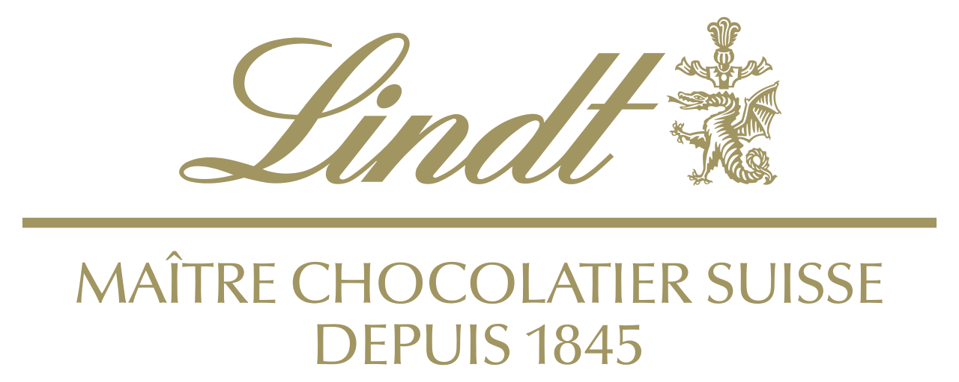
Lindt is a Swiss chocolatier and confectionery company known for its chocolate truffles and chocolate bars, among other sweets. It produces a wide variety of high quality chocolate including white and milk chocolate. Rodolphe Lindt was the first to introduce cacao butter to chocolate which made it more likely to melt in the mouth (Lindt.com) and generated a distinct secret recipe ever since. Lindt Chocolate also selects top quality beans from the best well-known cacao origins worldwide (Lindt.com).
Address: Seestrasse 204, 8802 - Kilchberg, Switzerland
Phone: +41 44 716 23 98
Fax: +41 44 716 26 54

Available sizes and price per unit
Lindt chocolate bars process range from approximately 2,000 L.L. to 9,000 L.L. depending on the chocolate type and size. Normally, Lindt bars are either 35g or 100g. Some bars however, go up to 140 and 150g.
Chocolate Bars (size in g) | Price per unit (L.L)
Lindt Excellence Dark (35g) | 2,017 L.L.
Lindt Excellence Creamy (35g) | 1,999 L.L.
Lindt Excellence (100g) | 6,300 L.L.
Lindt Excellence Sea Salt/ Dark Strawberry/ Orange/Cacao/Creamy (100g) | 6, 300 L.L.
Lindt Excellence White Vanille (100g) | 6,053 L.L.
Lindt Classic Milk Chocolate (100g) | 5,500 L.L
Lindt Lindor Milk Chocolate (100g) | 5,500 L.L
Lindt Crème Brulee (140g) | 8,577 L.L
Lindt Creation Mint (150g) | 8,577 L.L
Lindt Mousse Noir/ White (140g) | 8,577 L.L
Note: data on prices and unit sizes were collected from that provided by Spinneys.

Storage and shelf life
On average, a Lindt chocolate bar would last from 9 to 12 months. Stored properly, Lindt products with high cacao percentage can last as long as 15 to 18 months (lindtusa.com, 2013). The company informs the customer about the freshness and estimated shelf life of the product by printing a best before date on it (lindtusa.com, 2013). Optimal storage conditions of Lint chocolate bars are in a temperature of 15 to 20ºC in a cool dry place. Proper storage in appropriate storage conditions is important to prevent deterioration of quality and extend the shelf-life of the products to as long as a year (lindtusa.com, 2013).

Research and development
In 2008, Lindt launched the Lindt & Sprüngli Farming Program, a project that focuses in improving the challenging living and working conditions of the farmers in Ghana and thus preserving the best cacao (chocolate.lindt.com). The Lindt & Sprüngli Farming Program organizes the procurement of cocoa in four stages.
- Traceability and farmer organization: with the codes on the sacks they trace the cocoa beans to the farmers who grew and supplied them and thus improve conditions of the farmers in a more targeted manner (chocolate.lindt.com).
- Training and knowledge transfer: The program helps the farmers to improve their way of farming by giving training and transferring knowledge. They receive training in agriculture as well as environmental, social and business practices (chocolate.lindt.com).
- Farmer investments and community development: keeping with this program in Ghana and thus provide enough supply of clean safe water for the farmers. Farming Program invests in the set-up of farm shops, nurseries with new cocoa plants, demonstration plots where farmers are taught about good farming practices, plant protection products or pruning tools. Quite often, the local communities lack access to clean drinking water. This is why wells and boreholes were constructed. Other investments include village resource centers that give access to information and communication technology infrastructure, mosquito nets for malaria protection or school refurbishments (chocolate.lindt.com).
- Verification and continuous progress: Within the internal monitoring & performance management system, field staff visit each farmer participating in the Program at least once a year to see if the training content on agricultural, social, environmental and business aspects of farming is applied on the farms. Potential corrective actions are discussed together with the farmer and their implementation monitored. The ultimate aim is to measure the progress the farmers are making towards sustainable cocoa production. The Forest Trust visits each Program at least once a year to conduct external assessments, and to give recommendations for further improvement (chocolate.lindt.com).

Processing and Nutrition Facts

Ingredients
Flavor variations between milk chocolate and white chocolate are present because of differences in the way each type of chocolate is produced. Milk chocolate is made by combining cocoa solids, cocoa butter and sugar, and milk. White chocolate, which is white in color, doesn't contain cocoa solids like dark and milk chocolates do, but does have cocoa butter, milk and sugar in it.
LINDOR Bar White Ingredients: sugar, vegetable fat (coconut, palm kernel), cocoa butter, whole milk powder, skim milk powder, emulsifier (soya lecithin), flavorings. May contain hazelnuts, almonds.
Ingredients | Purpose
Cocoa Butter | Natural occurring fat in cocoa beans- it suspends and lubricates sugar particles. It lowers the viscosity of melted chocolate.
Sugar | Give a sweet taste
Milk | Deliver a creamy and smooth taste
Lecithin | Lecithin keeps the cocoa butter portion stable, so it doesn’t separate from the moisture and cocoa solids. Without lecithin, chocolate wouldn’t be as smooth.

LINDOR Bar Milk ingredients: sugar, cocoa butter, milk ingredients, coconut oil, cocoa mass, caramel paste (sugar, cocoa butter, cream, salt, soya lecithin), palm kernel oil, soya lecithin, barley malt extract, artificial flavour, and salt.
Ingredients | Purpose
Cocoa Butter | Natural occurring fat in cocoa beans. It suspends and lubricates sugar particles. It lowers the viscosity of melted chocolate.
Sugar | Give a sweet taste
Milk | Deliver a creamy and smooth taste
Lecithin | Lecithin keeps the cocoa butter portion stable, so it doesn’t separate from the moisture and cocoa solids. Without lecithin, chocolate wouldn’t be as smooth.
Cocoa Mass | Grounded to give chocolate liquor. This will give the chocolate its flavor.

Nutrition facts

LINDOR Bar White
Nutritional Information (100g)
Energy | 2688KJ /647Kcal
Fat | 51g
of which are saturates | 39g
Carbohydrate | 42g
of which sugars | 42g
Protein | 5.1g
Salt | 0.21g

LINDOR Bar Milk
Nutritional Information (100g)
Energy | 2294KJ /550Kcal
Fat | 33g
of which are saturates | 20g
Carbohydrate | 55g
of which sugars | 55g
Protein | 7.2g
Salt | 0.20g

Method of manufacturing
- Harvesting (chocolate).
- Cleaning the beans: a conveyor belt moves the beans through cleaning system. Twigs stones and other debris are removed (Chocolate, n.d.).
- Roasting the beans: revolving drum heat the cocoa beans to loosen their shells. The beans can be roasted at different temperatures and for different lengths of time, depending on different variables such as humidity, size of the beans, and the desired flavor. The process takes about 30 min to 2 hours and the moisture content is reduced from 7% to 1% (Chocolate, n.d.).
- Winnowing: cocoa beans enter a shell removing machine called a winnower. Inside, successive rigs drag the beans across screens, pulling off large pieces of shell. Then, a vacuum sucks away the remaining smaller pieces, removing the shell exposes the inside of the coca bean which is called the nib (Chocolate, n.d.).
- Roasting the nibs: the nibs are roasted to develop their flavor. More than 50% of the nib is fat, which is cocoa butter. To make chocolate, processed nibs, cocoa butter and sugar are combined, along with milk powder (Chocolate, n.d.).
- Grinding the nibs: heat and friction activate the cocoa butter producing pure liquid chocolate called chocolate liquor (Chocolate, n.d.).
- Adding and mixing the ingredients: the mixer blends the ingredients to the consistency of a very thick cake batter (Chocolate, n.d.).
- Refining: liquor is further ground between sets of revolving metal drums. Each successive rolling is faster than the preceding one because the liquor is becoming smoother and flows easier. The ultimate goal is to reduce the size of the particles in the liquor to about 0.001 inch (Chocolate, n.d.).
- Conching: now it needs to be re-liquefied. So the next stop is a machine called a conch. The friction and heat once again activate the cocoa butter, returning the powder to a liquid state. At this point they add more cocoa butter enough to reduce the viscosity to the exact thickness they need (Chocolate, n.d.).
- Molding: A depositor fills bar shaped plastic molds (Chocolate, n.d.).
- Cooling: the conveyor transfers them to an elevator system which moves through a cold room for about two hours. This constant motion ensures optimal air circulation, helping the cooling process (Chocolate, n.d.).
- Tempering: chocolate bars are heated then cooled many times to ensure a smooth and glossy surface (Chocolate, n.d.).
- Packaging

Flow Chart
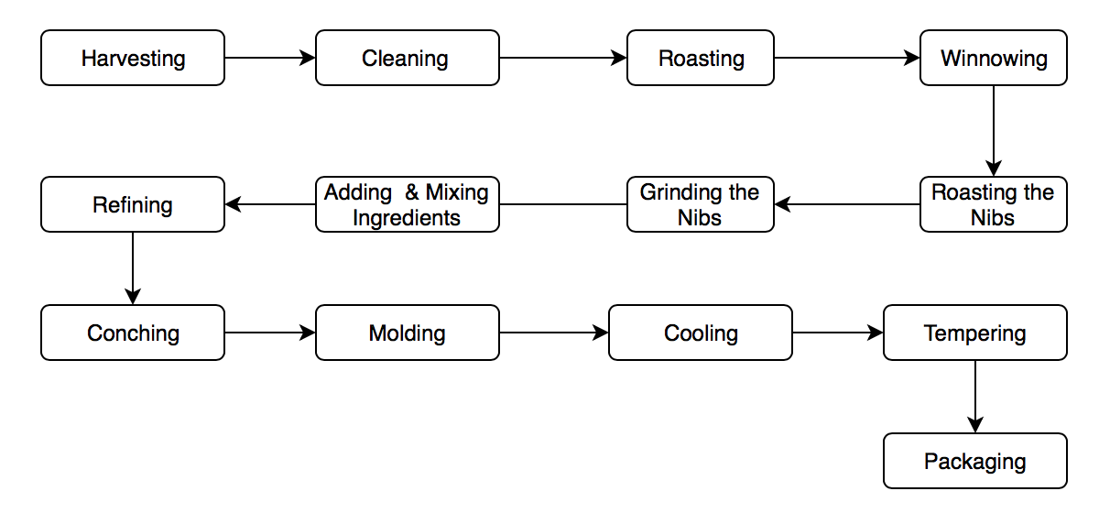

Packaging type and purpose of its use
The materials that are used at Lindt & Sprüngli have to fulfill the highest standards of composition, stability, hygiene, and odor neutrality. Lindt & Sprüngli found that aluminum foil is hygienic and provides the best protection for the products from odor, temperature and light. For outer packaging, Lindt & Sprüngli uses paper or corrugated cardboard. Minimizing the use of packaging material is also achieved by reducing the packaging's thickness and encouraging end-users to recycle (Lindt & Sprüngli).

Quality control tests
The company has proper ongoing internal and external quality control mechanisms. This quality control includes strict testing procedures, conducted on different levels from raw materials to the finished product. A careful evaluation of the distribution channels that sell Lindt & Sprüngli products and store them is an important part of our quality control system. The production process is divided into several levels, each of which has mandatory quality standards the product must fulfill in order to pass on to the next level. Chocolate products exceeding specified internal company limits are consequently rejected. All manufacturing units are inspected unannounced on an annual basis by an external Food Safety auditor. All Lindt & Sprüngli production sites have repeatedly and successfully passed the audit (Lindt & Sprüngli).

Cocoa beans
Cut Test | Done to check if the cocoa beans are well fermented. A number of fermented beans are cut in half and the fraction that is off color is noted. The color of the beans changes during fermentation; properly fermented beans are brown while purple and slate-colored beans are considered defects.
Taste | A small sample of beans may also be cleaned and roasted to make chocolate liquor, which is then taste-tested. If the taste is off, the roasting conditions can be adjusted.
Moisture Content | Determined by Karl Fischer titration or by infrared or microwave methods. Knowledge of the moisture content is needed to make sure the beans were roasted correctly.
Fat Content | Determination of fat content in seeds, nibs, and liquor. The fat content in seeds needs to be known to be able to formulate products correctly.
Fatty Acids | There is also interest in determining the free fatty acid content of beans and liquor since there have been concerns about the quality of beans from West Africa. The free fatty acid content is generally determined by wet chemistry techniques at this point.

chocolate
Moisture | 1%
Solid fat content | Solid fat content determination since it is a determinant of cocoa butter hardness
Temper | This is determined by a temper meter, which uses thermal analysis to determine whether the chocolate has achieved the proper cocoa butter crystals.
Microbiological tests | Roasting is the kill step in cocoa bean processing, killing pathogens (particularly Salmonella), and microbiological testing is conducted on the final chocolate.  The company also monitors: heavy metals, pesticides and extraneous material.
Other | - Gloss: by a gloss meter.  - Flavor: through sensory evaluation panels.  - Particle sizes: using a particle size analyzer.  - Viscosity: using a viscometer.  - Color: using a colorimeter.

Nutrient analysis per unit

Food Safety

Food Safety Management Systems
Food safety management systems according to ISO 22000 or FSSC 22000 have been successfully implemented at Lindt & Sprüngli Switzerland, Germany, Italy, France, Austria, USA as well as at Ghirardelli and Caffarel. Quality management systems according to ISO 9000 have been successfully implemented at Lindt & Sprüngli Switzerland, Germany, USA, Italy, France, Austria and Caffarel.

Spoilage
Chocolate and confectionery products have a good safety record. Most products, because of their low water activity, can be kept at ambient temperatures for several months or even one or two years. They are not especially susceptible to physical hazards, although occasionally stones or other hard objects can pose a problem in products containing raisins or nuts. Potential chemical hazards are quite limited, depending on agricultural, storage and distribution practices (Cordier, 1994).
Certain microbiological problems were found not to be of concern to public health. Spoilage, of certain types of confectionery products with an increased water activity by osmophilic yeasts is a phenlomenon known to occur periodically. However, due to the low water activity (a, = 0.4-0.5) in chocolate, which completely inhibits bacterial growth, this is not even a quality problem (Cordier, 1994).
For a long time, the only measures taken to avoid deviations affecting the quality of chocolate-based products were those related to the organoleptic and physicochemical characteristics. In the mid-1960s, however, several chocolate manufacturers were forced to recall their products after Salmonella cubana was detected in a pink summer coating. In response to this, the FDA began to look at salmonellae in confectionery products and issued the first minimum sanitation requirements, as well as some studies of the behavior of salmonellae in chocolate products (Cordier, 1994).
Fat bloom formation is the most common representation of spoiled chocolate. Chocolate of degraded quality, but absolute safety can still be considered spoiled. Fat in chocolate is in a stable crystal, which can be disrupted by high temperatures. High temperatures lead to fractions of the fat migrating out of the chocolate, forming a dusty white substance.
Concerning rancidity of fats, it is very less likely in dark chocolate. Cocoa butter contains a high portion of saturated fat and is therefore more resistant to rancidity than a highly unsaturated fat like flax seed oil. The main causes of rancidity of fats during storage are exposure to heat and light. Both of these are usually minimized in the case of chocolate after it is packaged and stored. Cocoa solids also contain anti-oxidants, which will help prevent oxidative rancidity.

Food borne incidences
The real problem of Salmonella, was recognized in 1972 & 1973, after two outbreaks which were clearly linked to the consumption of contaminated chocolate. In Sweden, cocoa powder contaminated with Salmonella durham and used in confectionery products caused an outbreak affecting 110 people . In Canada and the USA chocolate candy containing Salmonella eastbourne was at the origin of an outbreak involving 200 people, mostly children (Cordier, 1994).
In 1982 - 1983 an outbreak in the UK affecting 245 people, mostly young children, was traced to chocolate bars contaminated with Salmonella napoli and which were imported from Italy. Two outbreaks of salmonellosis linked with chocolate were registered in 1986. Some cases due to Salmonella nima reported in Canada were traced back to chocolate coins manufactured in Belgium. In Norway, more than 300 children were affected after the consumption of chocolate contaminated with Salmonella typhimurium. These outbreaks over the last 20 years have demonstrated that Salmonella represents a real hazard in chocolate and it is still a source of concern. Therefore, constant effort must be made to eliminate or minimize the risks of contamination with Salmonella during chocolate production by introducing preventive measures based on the HACCP system and by adherence to good manufacturing practices (Cordier, 1994).
In Sweden, cocoa powder contaminated with Salmonella used in confectionery products caused an outbreak affecting 110 people (1972) (Cordier, 1994).

References
Chocolate Bars | All Formats. (n.d.). Retrieved April 25, 2018, from http://www.chocolate.lindt.com/shop/format/chocolate-bars
Chocolate. (n.d.). Retrieved from http://www.madehow.com/Volume-1/Chocolate.html
Clean drinking water for cocoa communities. (n.d.). Retrieved April 25, 2018, from http://www.chocolate.lindt.com/world-of-lindt/sustainability/clean-drinking-water/
Cordier, J. L. (1994). HACCP in the Chocolate Industry. Retrieved April 25, 2018, from https://courses.ecolechocolat.com/lobjects/pdf/FOOD_CON_5,171-175.pdf
FAQ. (n.d.). Retrieved April 25, 2018, from https://www.lindtusa.com/faq
Fiegl, A. (2008, March 01). A Brief History of Chocolate. Retrieved April 25, 2018, from https://www.smithsonianmag.com/arts-culture/a-brief-history-of-chocolate-21860917/
Gidwani, P. (2015, June 03). Package and Packaging. Retrieved from https://prezi.com/xytot0olwft0/package-and-packaging/
Greene, A. (2017, December 07). Soy Lecithin: Why Is It In Everything? Retrieved April 25, 2018, from https://www.huffingtonpost.com/amanda-greene/soy-lecithin-why-is-it-in_b_2891780.html
Ingredients in Chocolate. (n.d.). Retrieved from http://chocolat.bz/All about chocolate/ingredients in chocolate.html
Klein, C. (2014, February 13). The Sweet History of Chocolate. Retrieved from https://www.history.com/news/hungry-history/the-sweet-history-of-chocolate
Lee, Linda. A Very Brief History of Chocolate. 17 Nov. 2017, www.eatsiptrip.10best.com/2017/11/17/a-very-brief-history-of-chocolate/
LINDOR Bar Milk. (n.d.). Retrieved April 25, 2018, from http://www.chocolate.lindt.com/shop/lindor/lindor-bar-milk
LINDOR Bar White. (n.d.). Retrieved from http://www.chocolate.lindt.com/shop/lindor/lindor-bar-white
Material efficiency. (n.d.). Retrieved from http://www.lindt-spruengli.com/sustainability/sustainably-produced/material-efficiency/
Mermelstein, N. H. (n.d.). Chocolate Quality Testing. Retrieved April 25, 2018, from http://www.blommer.com/_documents/chocolate-quality-testing.pdf
Packaging material. (n.d.). Retrieved April 25, 2018, from http://www.lindt-spruengli.com/sustainability/sustainably-sourced/packaging-material/
Product quality & food safety. (n.d.). Retrieved April 25, 2018, from http://www.lindt-spruengli.com/sustainability/sustainably-consumed/product-quality-food-safety/
Roberts, A. (2012, March 21). Why is chocolate so slow to spoil? Retrieved April 25, 2018, from https://www.quora.com/Why-is-chocolate-so-slow-to-spoil
Story of Lindt. (n.d.). Retrieved April 25, 2018, from https://www.lindtusa.com/
The History of Candy Bars. (n.d.). Retrieved April 25, 2018, from http://www.candyhistory.net/candy-origin/candy-bars-history/
Wit, A. D. (2018, March 29). Chocolate: The good, the bad and the tasty. Retrieved from https://theday.co.uk/briefing/chocolate-the-good-the-bad-and-the-tasty

